***HISTORY OF NATIONAL AI DAY***

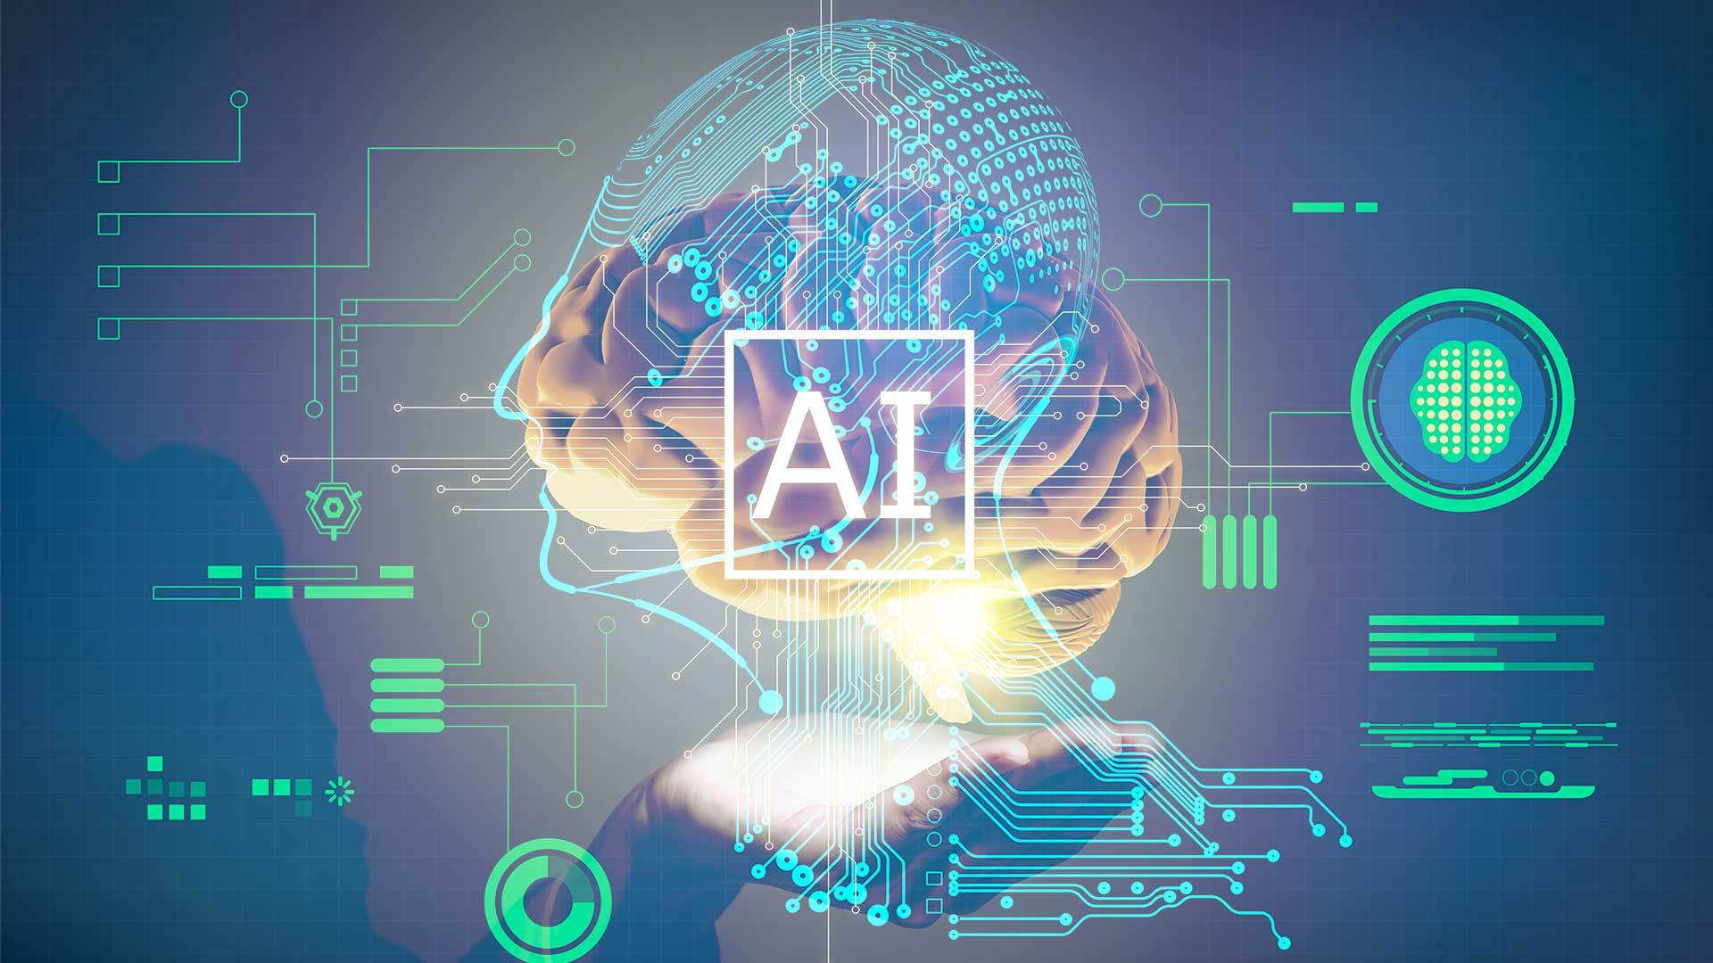

This National ‘Ai’ Day, celebrated on April 26, you’ll get to learn about the meaning behind this Chinese and Japanese word. ‘Ai’ means ‘adoration,’ ‘affection,’ or ‘love.’ The word is used almost exclusively as a female name in Japan, but boys are sometimes given it in Chinese too. Notable figures such as Ai Wei Wei, Ai Sugiyama, and Ai Otsuka share this name, and dozens of videogames, cartoons and fantasy characters with the name appear across Japanese and Chinese media. It’s pronounced similar to the word ‘eye’ in both cultures, but the kanji (Japanese) inscriptions differ from the hanzi (Chinese) characters .pril Holidays00:11/02:3  ***HISTORY OF AI***

Ai Wei Wei is a Chinese activist and artist known in the East and West for his creative works. Because he is known for being politically outspoken and the divisive nature of his art, Wei Wei is persecuted by repressive government authorities. In 2005 he began using social media as a tool for social commentary. In 2009 his blog website was shut down. He moved to Twitter and continued online journaling from there, much to the dismay of the Chinese government. This led to Wei Wei’s house arrest in 2010 and subsequent arrest in 2011 at Beijing airport. He was then jailed for unspecified crimes but got released after serving three months in prison. Ai Wei Wei now lives in exile in Portugal and remains a critic of the Chinese Communist Party.

Japanese tennis star Ai Sugiyama held the record for male and female players in 62 consecutive Grand Slam main-draw appearances until 2015 when Roger Federer surpassed her. Sugiyama began playing tennis at 17, debuting at Wimbledon against world number 30 Gigi Fernandez. Throughout her nearly 20-year career, she rose to the world number one ranking in the WTA, winning the U.S. Open in 1999 and 2000, the French Open in 2003, and Wimbledon in 2003. She retired in 2009 after the Pan-Pacific Open and now teaches aspiring tennis players in Japan.

Ai Otsuka is a Japanese singer-songwriter famous for her song “Sakuranbo,” released in 2003. The 39-year-old musician was a child prodigy who began playing the piano at age four and writing songs in her teens. Trained as nursery teachers, Otsuka and her former classmate Mami Nishida started to record and upload music online in the early 2000s, sending demo tapes to studios with little success. In 2003 the popularity of “Sakuranbo” got Otsuka signed to Avex Trax, one of Japan’s biggest record labels. In 2004 she released her debut album “Love Punch,” which peaked at number three on Japanese music charts and sold nearly 200,000 copies in its first week.

World Artificial Intelligence Day will reflect the theme of the importance oftrust, ethical approaches, innovation, and the public good in national systems introducing AI. The celebration is a global collaborative endeavour organised under the guidance of IRCAI and UNESCO, defining key global messages and making outreach resources available to countries and other partners through IRCAI’s website.

Considering that Artificial Intelligence significantly affects important areas such as international peace, ethics, sustainability, and development, UNESCO launched a global online consultation on the ethics of artificial intelligence, giving everyone around the world the opportunity to participate in the work of its international group of experts on AI.

IRCAI has been charged with analysing the comments on the first draft of a Recommendation on the Ethics of AI, which is to be submitted to UNESCO Member States for adoption in November 2021. If adopted, this Recommendation will be the first global normative instrument to address the developments and applications of AI.

IRCAI endorses the view that World Artificial Intelligence Day would be an asset for both the organisations’ image and visibility, particularly in the context of the follow-up to the Recommendation on the Ethics of AI.

IRCAI will invite Member States and the Director-General to develop a feasibility study and (ii) contribute to the establishment and implementation of World Artificial Intelligence Day, (iii) support recognized national, regional, and international activities undertaken as part of this annual celebration, and (iv) encourage Member States, intergovernmental and non-governmental organisations, universities, research institutions, learned societies, professional associations, and schools to take an active part in the event.

PICTURES OF AI

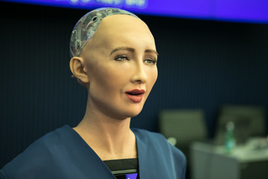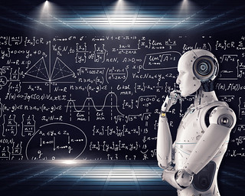

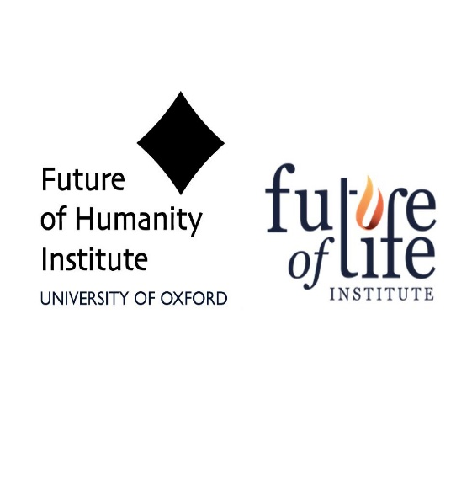 *MADE BY neema*